HASHMAP NOTES

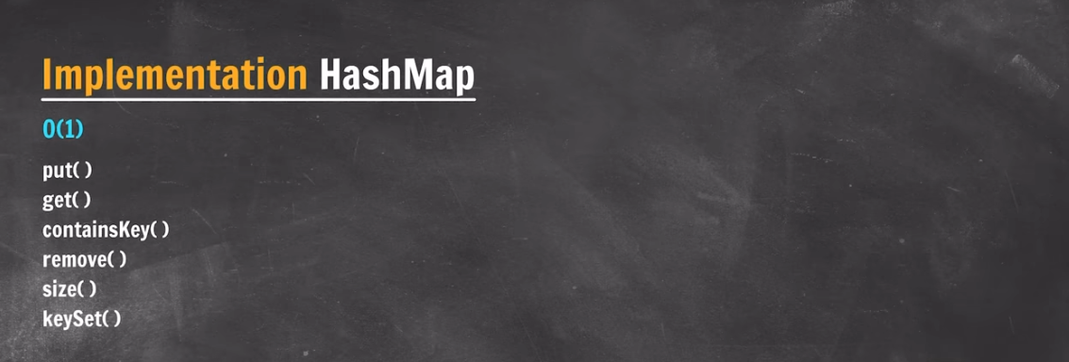

**HashMap is internally implemented as arrays of LL**

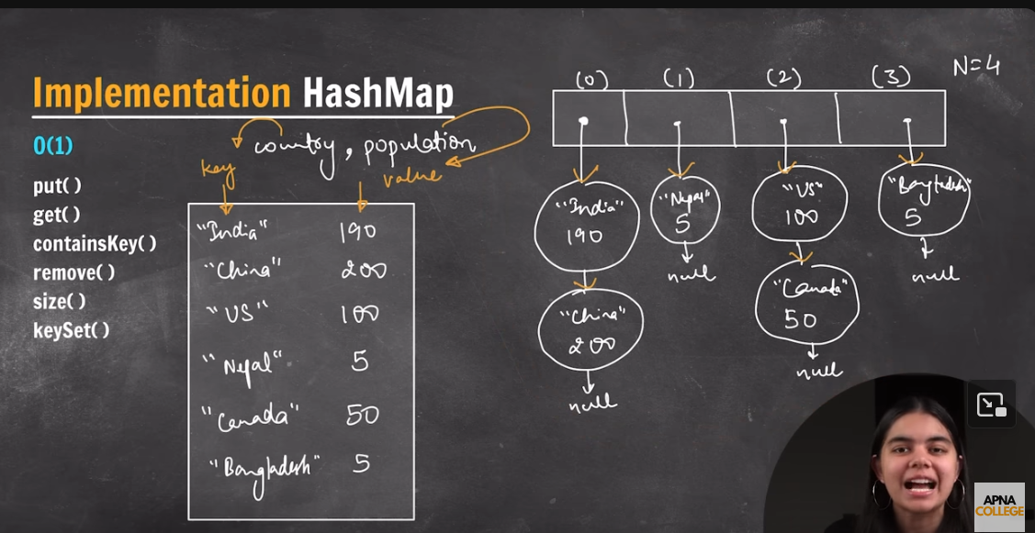

Hashing = Data ki form change karna

Hashing Algo = SHA1,SHA256

In Hash function every time if you pass the same value you will get same output result.

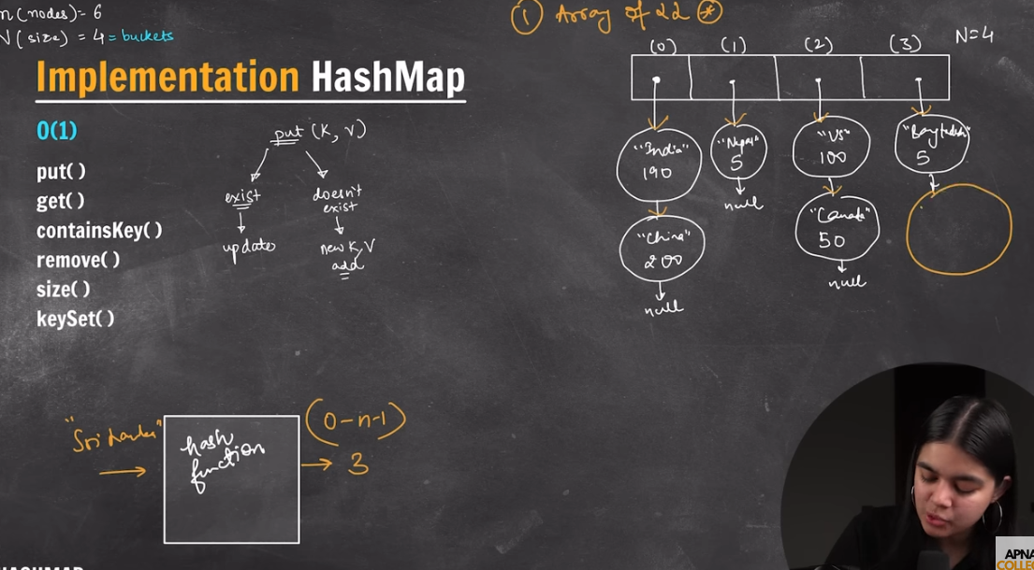

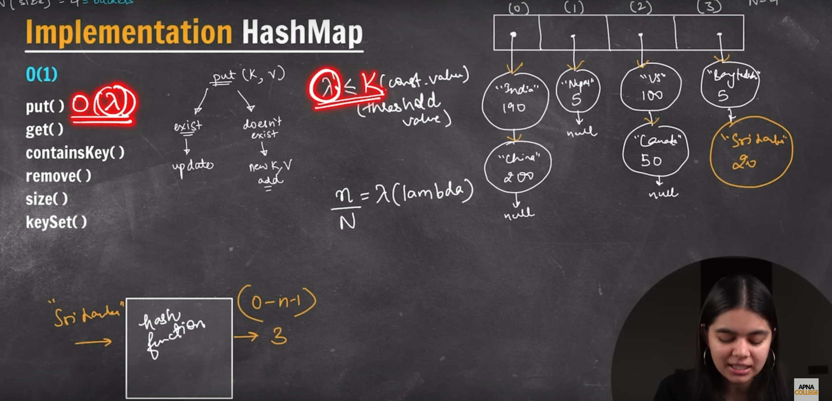

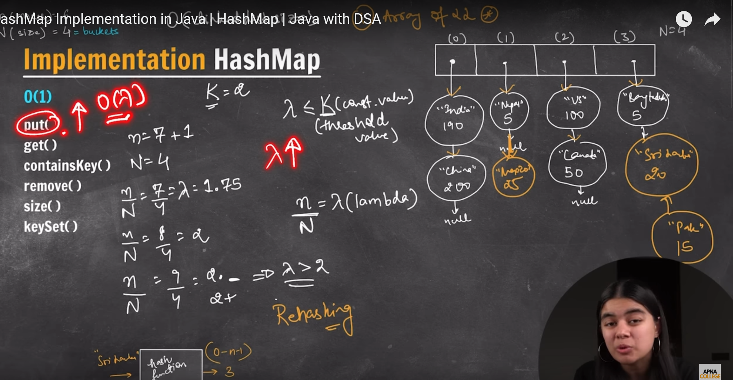

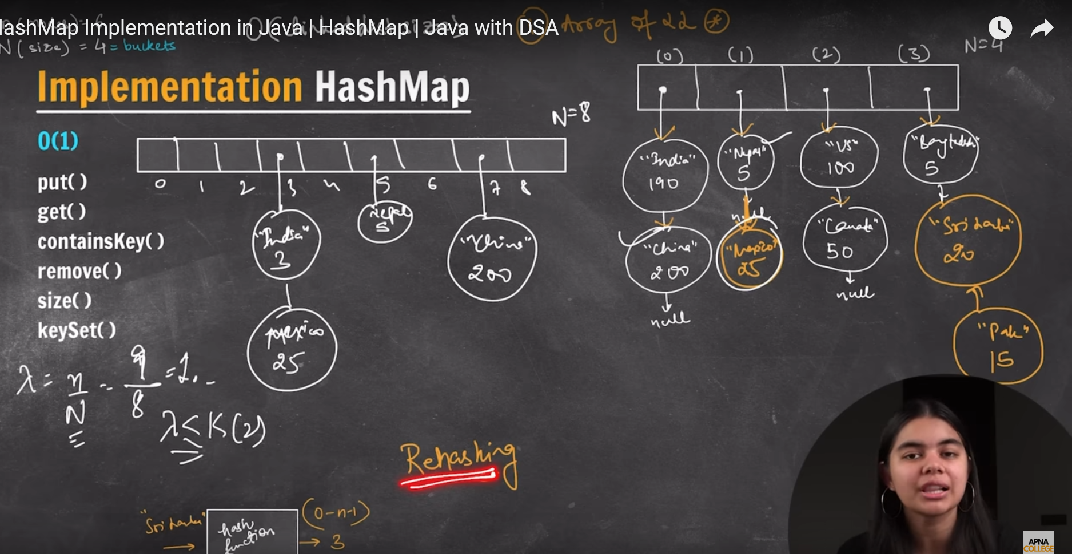

If the Arrays size changes then Bucket Index also changes

Hash function = Takes key as an input and returns the bucket index

Put() = Best case complexity = O(lambda)

Worst Case complexity = O(n)